Workshop 1: Introduction Scratch and Sequence

What is Scratch?
To quote the system’s own web site...
“With Scratch, you can program your own interactive stories, games, and animations — and share your creations with others in the online community.
Scratch helps young people learn to think creatively, reason systematically, and work collaboratively — essential skills for life in the 21st century.
Scratch is a project of the Lifelong Kindergarten Group at the MIT Media Lab. It is provided free of charge.”
There are two points to keep in mind as an educator new to the environment.
- Scratch is simple, easy, and fun to use
- Scratch teaches core concepts of programming that extend into the usage of pretty much every modern programming language used in industry today
These two points combined to make Scratch an excellent environment for children to engage with and understand key programming concepts and skills.

So how does it work?
Take a look at the following C sharp code, (a popular modern computer language). Most programming languages tend to look something like this when displayed on the computer screen.
//create an infinite loop
while (0 == 0)
{
//if the user presses space then move the sprite ahead 20 units
if (GetKeyPress() == "space")
{
MoveSprite(20);
}
//if the user presses the right arrow rotate by +20
if (GetKeyPress() == "right arrow")
{
TurnSprite(20);
}
//if the user presses the left arrow rotate by -20
if (GetKeyPress() == "left arrow")
{
TurnSprite(-20);
}
}

Not only does this look like total misery, please be clear it is total misery! Comprehending the text is near impenetrable for a novice, make one single typo (miss out a semi colon)and the program won’t work also there is a significant learning curve associated with this approach to programming.
Below is a Scratch program that does exactly the same as the code above but in a much easier to grasp format.
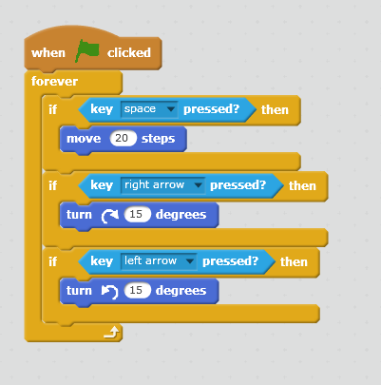
Scratch instructions operate like jigsaw pieces. If two instructions go together then the shape of each piece will give a clue that this is the case (mostly). If the shapes don’t match, then the odds are that the logic isn’t right.
The C sharp code above and the Scratch code use exactly the same concepts to get the job done but in the case of Scratch, a layer of complexity is removed (notably syntax) making it much more accessible to younger programmers. This means we can teach the programming concepts that apply to all languages without creating a barrier to those wishing to learn.

Elements of a Computer Program
Pretty much all programming languages consist of the following elements.
- Sequence
- Selection
- Repetition
- Assignment

Sequence
Sequence relates to placing instructions in the correct order such that the intended outcome is achieved.
Consider the following sequence of instructions for making toast...
- Butter toast
- Insert bread into toaster
- Turn on the toaster
- Slice bread
Clearly the sequence of events is not correct for making toast. The same issue needs to be considered when writing instructions for the computer.

Selection
Selection relates to making changes to the normal sequence of activities if a certain set of conditions happen to be true.
Consider the following sequence for making toast...
- Slice bread
- Insert bread into toaster
- Turn on the toaster
- If toast is burning then remove the bread
- Butter toast
In this case we have added a conditional step which only takes place if the toast is burning.

Repetition
Repetition takes place when we can’t complete a certain task in one cycle of activity.
Let’s assume we have a four slice toaster. If we are making four rounds of toast or less then we can complete the task in one go. If however we want to make eight slices of toast we must repeat the main task until all of the bread has been toasted.
The extended logic may look something like this...
- While there is bread to toast do the following
  - Slice bread
  - Insert bread into toaster
  - Turn on the toaster
  - If toast is burning then remove the bread
  - Butter toast
- Repeat the from the start if required

Assignment
Assignment is a bit of an abstract idea, however it is a really important to how computer programs operate. This relates very much to variables which we shall look at in a few weeks.
To assign something in a computer is to take some data from one part of a system and place it somewhere else in the system.
To stretch the toast metaphor to breaking point, inserting the bread into the toaster is the point of assignment, i.e. the bread is the data to be processed by our system and once processed comes out as toast!
More on this when we get that far though!
As we learn the basics of Scratch we will see how the environment supports each of the above. In this session we shall look at sequence.

How do I get Scratch?
Scratch is freely available via the web by visiting...
https://scratch.mit.edu
You will need to create an account to access the full range of features. (There is also a downloadable version that allows you to use Scratch off-line should you feel the urge!)

Creating your first Project
Once you have signed up and logged on you should see a drop down menu with your user name displayed...
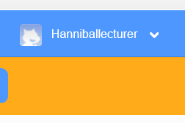
Drop this list down and you should see the option called “My Stuff”...
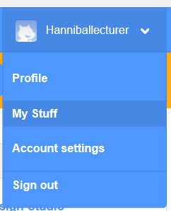
Here you will find the option to create a new project...
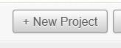

Naming your Project
To name your project to something more informative than “Untitled” overwrite the default text with a project name of your choice, for example, “my first project”.
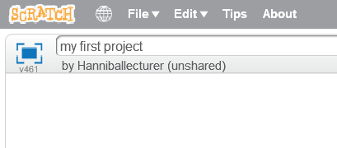

A Quick Tour of Scratch
Once you have created a new project in Scratch you will see the following screen...
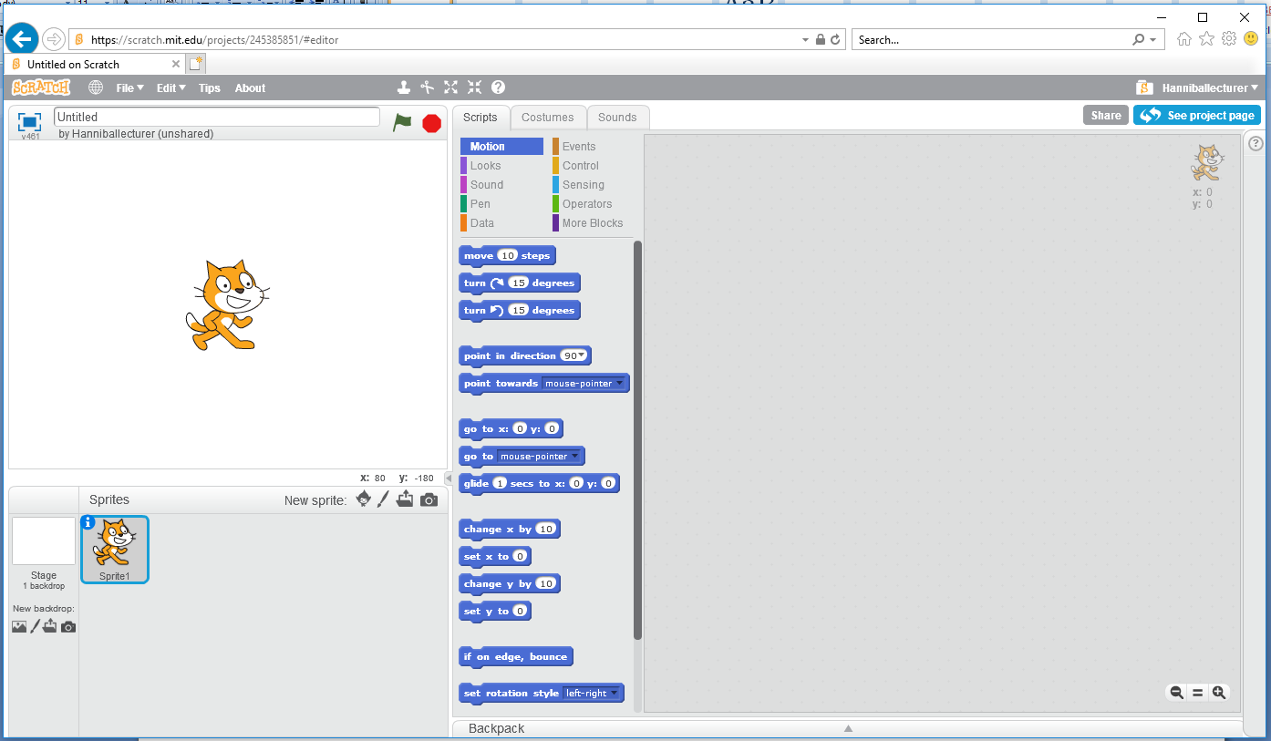
To the left is the stage area where the action happens...
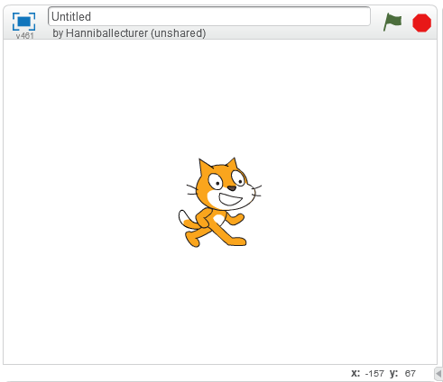

Sprites
The cat in the centre of the stage is named Scratch the cat. From a technical perspective this is an example of a sprite.
A sprite is an image which we are able to send instruction to make it do something, e.g. move by so many units, turn by so many degrees.
Each sprite has two things associated with them.
- Properties that allow us to adjust the settings of the sprite
- Scratch code that allows us to tell the sprite to do something or respond to different triggers in certain ways

Properties
If you look under the stage area we can see the sprites for this project (currently only the one).
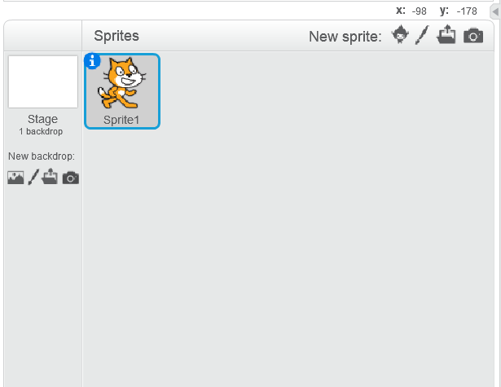
Notice how the sprite has a small “i” symbol in the top left hand corner...
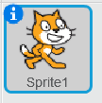
Click this to access the sprite’s properties like so...
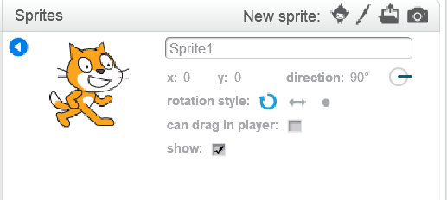
The first property we shall change is to give the sprite a meaningful name like so...
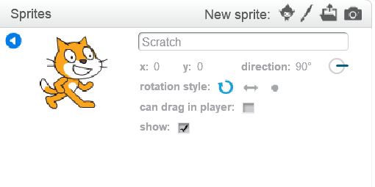
In this example we have called the sprite by their true name which is “Scratch”.

What was the point of that?
Giving meaningful names is the first thing to learn in any programming language.
Imagine we had a roomful of 50 students all called Alice? How would we be able to ask a specific Alice to perform a specific task without the whole room getting confused?
The same is true for programming languages.
The first sprite in Scratch is called Sprite1. Can you hazard a guess as to what the next sprite will be called? Correct, Sprite2!
As you advance in your skills in writing Scratch projects you will be creating multiple sprites. If you let Scratch name your sprites Sprite1 to Sprite100 it will be very easy to become confused.
Get into the habit now of giving your sprites meaningful names and it will save a lot of pain later on. (This is true of all programming languages!)
If you press the blue triangle you can collapse the properties window for the selected sprite.
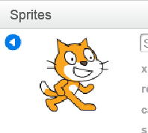
Such that it looks like so again...

Writing some code
Having given the sprite a meaningful name we are now in a position to write code for the sprite. We need to make sure we have done one important thing to do this, that is make sure that the sprite we want to code has been selected.
What does that mean?
In the following project there are two sprites...
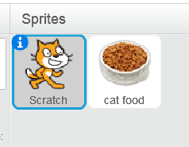
In this screen shot the Scratch sprite is selected.
In the code window to the right of the main screen we can see the code attached to this sprite.
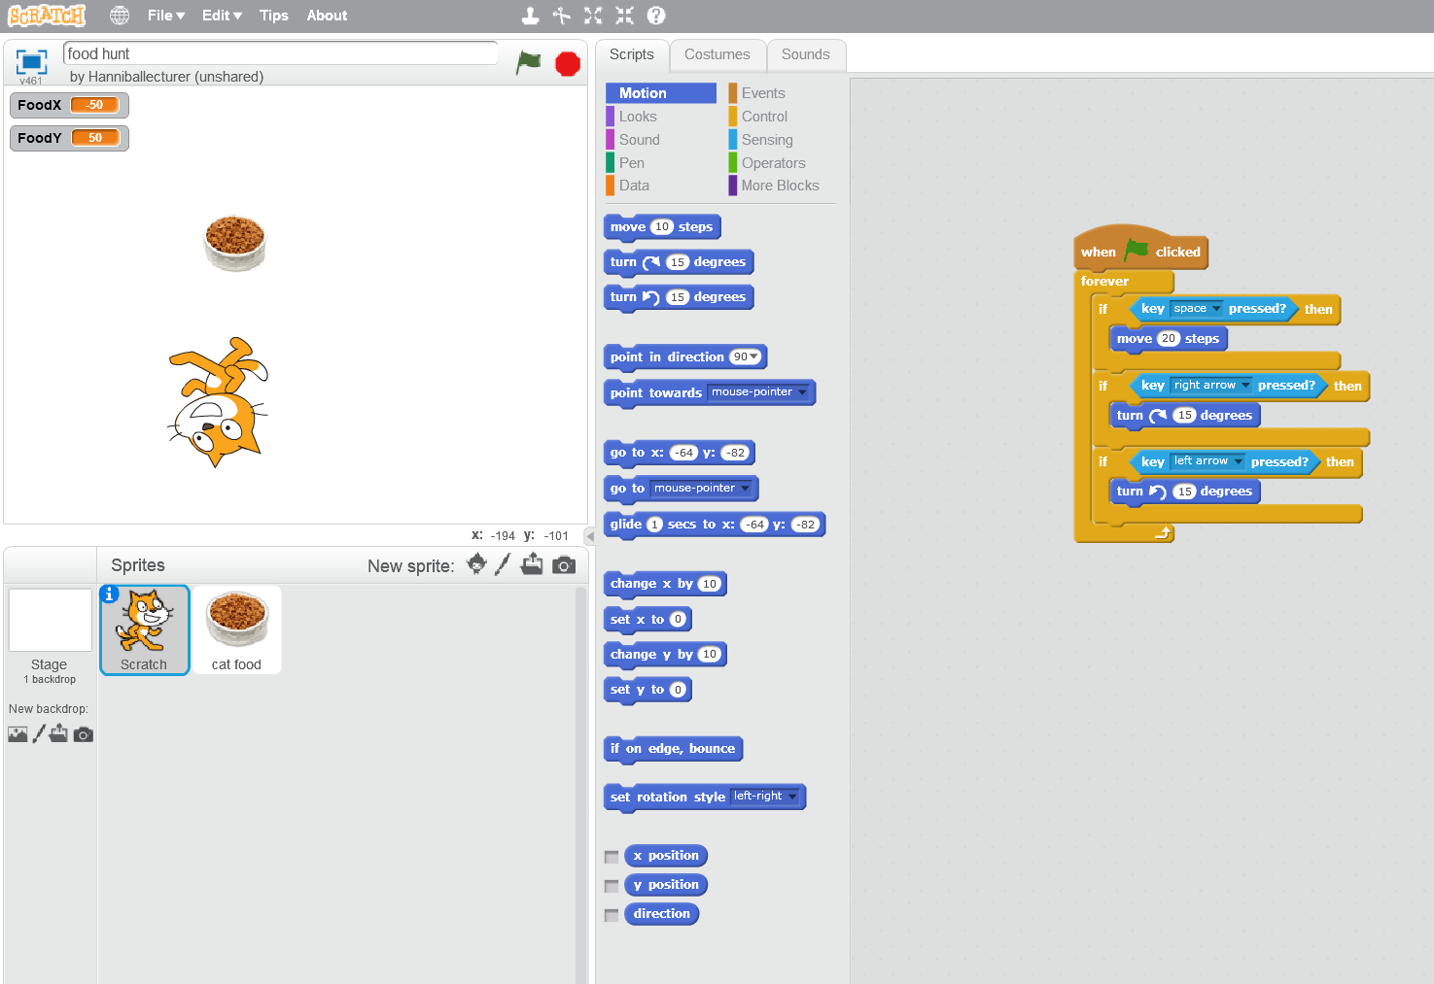
If we now click on the other sprite like so...
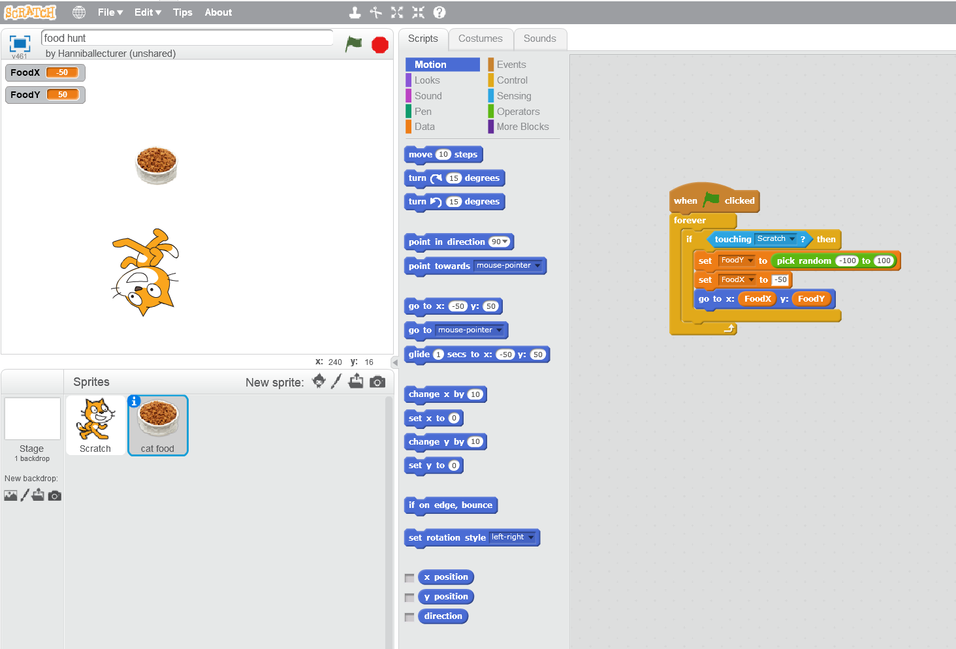
The code window will display the code associated with the sprite called “cat food”.
Granted, so far in your work we only have one sprite (Scratch) but like giving objects sensible names it a good to be aware of this right from the beginning.

Let’s do something then!
OK, we have one sprite called Scratch and we want to write some code.
Rather than typing code in Scratch we use modular shapes that link together. The logic works in exactly the same way other programming languages do, the advantage here is that we don’t have to type each command.
Instructions in Scratch are accessed via the scripts tab...
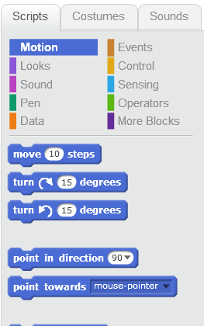
There is a lot here but try clicking through “Motion”, “Looks” etc to get a sense of what is there.
Let’s make our sprite say something.
Under “looks” find the instruction for “say”...

Using the mouse, drag the instruction over to the code area such that it looks like this...
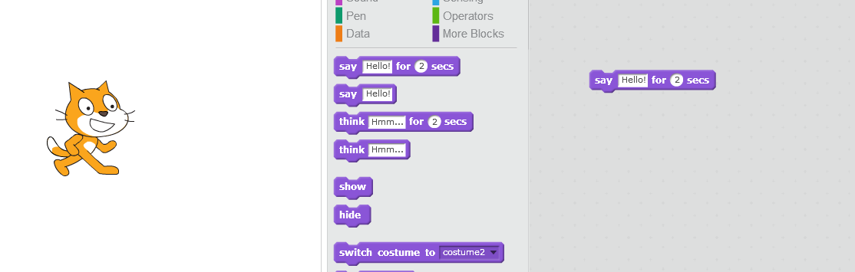
Activate the command by clicking once on it with the mouse.
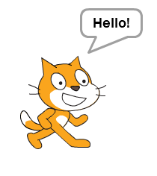
That’s all well and good but what if we wanted the sprite to say “Hello” for two seconds and then “Goodbye” for three seconds?
We could try the following set of instructions...
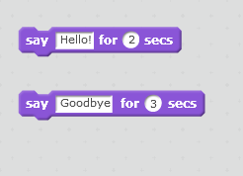
Note at this stage we haven’t linked the instructions into a script.
This means that to activate each command by clicking it manually ourselves, (try that now) for me it is too much like hard work!
To make this run more effectively, let’s join up the instructions to form a script.
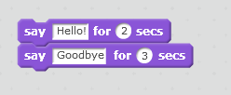
Drag the instructions to each other until they lock. Note that the shapes of each instruction are compatible indicating that we may link them together without any problems.
We have now created a simple “sequence” of commands as you would in any other programming language.
Now click the first instruction and you should see the second instruction follows on automatically.
Followed by...
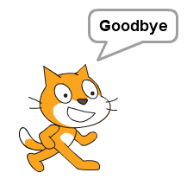

Using Events
Events are common to many programming languages and they are basically “things that happen to the system”.
For example if a user presses the keyboard, this triggers a “key press event” which might be used to find out if a certain key has been pressed.
One important event in Scratch is triggered when the green flag is clicked...

The green flag may be used to start the entire Scratch project running.
If we capture this event in our code then it will trigger the first part of the program.
To do this we need to access the events section of the scripts, like so...
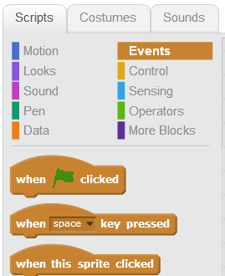
Now drag the following event onto the code area and assemble everything like so...
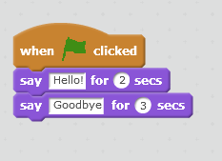
To check that everything works press the green flag button rather than the first line of the script. It should work exactly as before.

Creating Additional Sprites
When the time comes to adding sprites to your project there is an extensive library of built in sprites available.
To add a new sprite, select the library from the Sprites area...
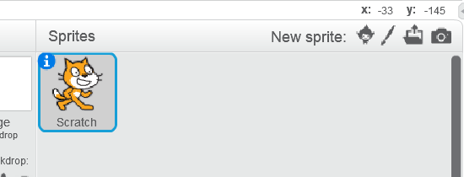
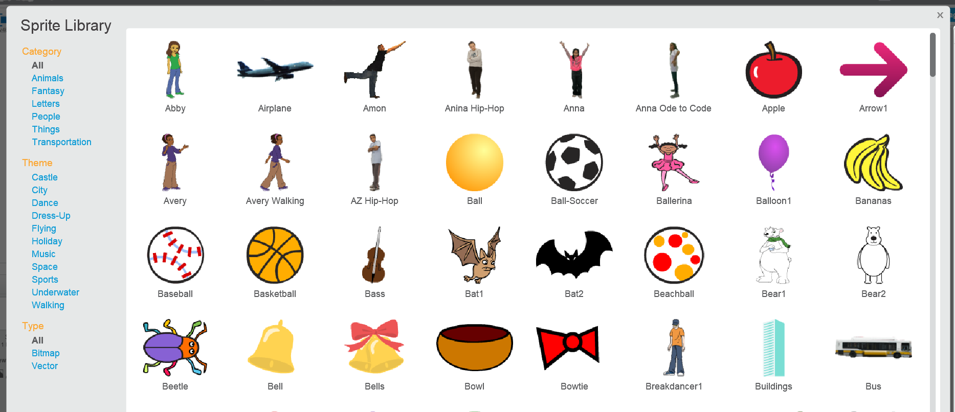
Double click the sprite to add it. Once added tidy up the stage a bit if they overlap, and.........
Don’t forget to give it a sensible name!

Exercise
You have been provided with two documents in the Blackboard shell.
The first document is...
Perils of Discovery Methods and Student Power.pdf
Boyson, R
The second document is...
TeachingSectionFromCASPrimaryGuide.docx
Papert, S

Working Together
One key to success in programming is working together. In industrial practices such as Pair Programming and SCRUM collaboration is an embedded requirement. So, in keeping with that principle work together as at least pairs to do the following.
Look at the two documents and get a sense of what each writer is saying about how students learn. What is the gist of their arguments?
Once you have a sense of what each person is saying write a script in Scratch with two sprites that have a brief conversation. Use one sprite to represent Boysen and a second Sprite to represent Papert.
What might they say to each other? It may be a good idea to plan out the script in word first in order to plan out the timings of the conversation.
Since you will have two sprites in conversation you will need two scripts running simultaneously. This means that while one sprite is talking the other sprite will need to wait.
Access the “wait” instruction under the “Control” tab...
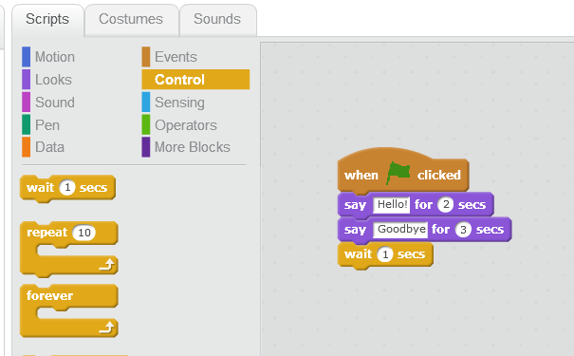

Extension Task
Can you make the conversation take place in a disco?
You might like to find a suitable backdrop and also try out the following blocks...



